**Intro to Programming in Python — Final Project Specification**

**UW Robinson Center (Summer Stretch 2024)**

Overview

We have spent 3 weeks getting to understand and explore Python programming and different fundamental concepts in coding! Now it is your time to show us what you have learned and use your imagination/problem solving skills to code a final project in Python.

For your final project, you will have the choice to choose from the following prompts OR create your own project, as long as you ask for permission by the course instructor(s) and incorporate 3+ concepts from the course (more details below).

You will be graded on 3 components:

1. Code (Jupyter Notebook)
2. Presentation
3. Peer feedback form

Format

The project must be submitted as a Jupyter Notebook using Python. External files are allowed as complements to the source code if they are necessary for your project.

Students will also present their project on Thursday, Jul 25 (the last day of the course). All students must present, and it must be in the form of a PowerPoint, slide presentation, or/and Jupyter notebook demonstration.

Lastly, students will evaluate each other’s participation in the project using a [Google Form](https://forms.gle/1rYuhj43kzntmqpj9). These will be for teachers’ and TA’s eyes only.

Project – Coding Portion

The final project will be worth 30% of your final grade. Students should work in groups of 4+. We (the staff) will assign the groups. The final group assignments are [here](https://docs.google.com/spreadsheets/d/1_Z3RFul0LP66JNdlLJ4HKHAbh5IUp5_ntW3v_diRE2c/edit?usp=sharing).

You may choose from any category of project options, but must sign up on this sheet with your group for particular slots. If you are choosing project 2, 4, and 5, you will need to sign up for a particular dataset – with only 1 group allowed per dataset.

The kinds of projects can be shown below, with templates of our expectations. More detailed explanations can be found in the project rubric.

*\*NOTE – all examples and templates are only for REFERENCE; do not copy code or you will be marked down in your grade.*

1. Turtle Art

*Instructor Mentor: Shananda Dokka*

For this project, you can make use of the Python library [Turtle](https://docs.python.org/3/library/turtle.html) to create your own artwork. While this is the most open-ended project, we require that you create a more advanced design. Please consult the instructor mentor.

* Examples (refer for complexity level expected):
  + [House Sketch](https://www.shutterstock.com/image-vector/house-building-construction-260nw-231738901.jpg)
  + [Street Sketch](https://i.ytimg.com/vi/yOk7bP7fKbg/maxresdefault.jpg)
  + [Fruit Bowl Sketch](https://www.supercoloring.com/sites/default/files/styles/how_to_draw_medium/public/htd/2015/09/bowl-of-fruits-0-how-to-draw.png)

1. Data Analysis

*Instructor Mentor: Bella Chang*

For this project, you can explore data analysis and data visualization with a public dataset. You will work with uploading datasets, counting certain features of the dataset, and visualizing your findings with data visualization libraries including [Matplotlib](https://matplotlib.org/) and [Plotly](https://plotly.com/).

* Examples:
  + [Instagram Reach Analysis](https://thecleverprogrammer.com/2022/03/22/instagram-reach-analysis-using-python/?source=post_page-----af033e6ec38f--------------------------------)
  + [Smartwatch Data Analysis](https://thecleverprogrammer.com/2022/05/31/smartwatch-data-analysis-using-python/?source=post_page-----af033e6ec38f--------------------------------)
  + [iPhone Sales Analysis](https://thecleverprogrammer.com/2022/09/19/iphone-sales-analysis-using-python/)
  + [Advanced – dashboard] [Customer Segmentation using Interactive Dashboard](https://thecleverprogrammer.com/2024/01/01/analytics-dashboard-using-python/)

1. Making a Game

*Instructor Mentor: Xuetao Ma*

For this project, you are asked to recreate a classical game using python. Examples can be:

* + Hangman (Example):
    - Description: The player tries to guess a hidden word by suggesting letters within a certain number of attempts.
    - Each incorrect guess reveals a part of a hangman.
  + Snake Game:
    - Description: The player controls a snake that moves around the screen, eating food to grow longer while avoiding running into itself or the screen borders.
  + Minesweeper:
    - Description: The players try to flag all mines and discover all unmined fields.

Your own idea is welcomed! Check with the instructor if you have other ideas!

1. Basic Machine Learning

*Instructor Mentor: Bella Chang*

For this project, you can build your own first basic machine learning model, choosing between classification or regression, from a public dataset. You will be able to map trends and create future predictions for a particular topic. You can make use of machine learning libraries like [sklearn](https://scikit-learn.org/stable/).

* Examples:
  + [Regression] [E-commerce customers](https://www.kaggle.com/code/punit0811/machine-learning-project-basic-linear-regression)
  + [Classification] [Fruit categorizing](https://towardsdatascience.com/solving-a-simple-classification-problem-with-python-fruits-lovers-edition-d20ab6b071d2)
  + [Advanced – regression] [Car mileage](https://anar-abiyev.medium.com/data-science-regression-project-example-8bf12f76a71)
  + [Advanced – classification] [Wine quality](https://towardsdatascience.com/a-comprehensive-guide-to-a-classification-project-data-cleaning-and-exploration-88edd5617ce2)

1. Build an App Interface

*Instructor Mentor: Xuetao Ma*

Once the code is done, an interface is needed for the users to interact with the code without understanding what is going on behind the scenes. Thanks to tkinter module, which is the standard Python interface to the Tk GUI toolkit, we can create user interfaces easily.

* Simple Calculator Interface (Example)
* Temperature Converter Interface.
  + Mimic the temperature detector interface that we usually see on market.
  + Add a button that can swap the temperature display from Celsius to Fahrenheit.
  + Comments: you can use python_weather to get current temperature.
  + 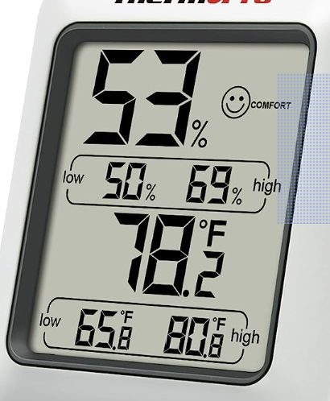
* Text Editor Interface
  + Mimic the famous, current, text editor.
  + Implant save, load functions to allow users to save to and load from a local .txt file.
  + Implant renaming function to allow users to change the name of the file.
  + 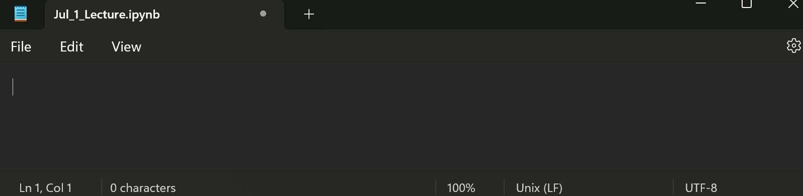

1. Make Your Own

*Instructor Mentor: Bella Chang, Xuetao Ma*

For this project, you can do anything you want (as long as you run it by our instructors)! You must use 3+ concepts from the course, which will be further detailed in your write-up. Topics are below for your convenience:

* Conditional statements
* Functions
* Recursions
* Data structures (lists, tuples, sets, dictionaries)
* String manipulation
* File I/O
* Error handling
* Object oriented programming (OOP)